**Why Chicago Needs More Ninja Gyms**

***Introduction***

1. *Background*

Has anyone ever heard of gyms? Of course, you have. I don’t think there is anyone here that has not heard of one. They are prevalent everywhere. You hear about them on the television telling you to join their gym. Now has anybody heard of specialty gyms? Some examples of a specialty gym would be an indoor rock-climbing gym, cross fit and obstacle course gym.

1. *Problem*

There is one gym that has been here, but has been under-utilized. These are Ninja gyms. I know just that phrase “Ninja” can feel silly when saying it, but these are real people. Not the ones that hide in the shadows and dress in black. These are people from the televised competition *American Ninja Warrior*. These people are considered “Ninjas” because they run through a course designed to test their endurance, will, and skill.

1. *Interest*

Why am I talking about this? Well there is a large fanbase in the Chicagoland area. A large majority of the competitors are more Chicago or the suburb surrounding Chicago. Men, women, and children watch anxiously as they see their hometown heroes compete and show the world what they are made of.

This is the point that I am trying to drive is that there is a large fanbase in Chicago/Northern Illinois, where fans and kids want to perform obstacles like their heroes on the show. They can go to a local gym, a “Ninja” gym that house all the obstacles for them to practice on, but they are too far most of them being located in the downtown area. The only other option is for them or their parents to build obstacles in their backyard. Unfortunately, that takes a large amount of time, and a large amount of money. Another option would to be open more gyms in the Chicago suburbs.

**Data Being Used**

1. *Cost and Profit*

Through this report, I will be using data that consists the average monthly membership costs of all the different gyms including traditional, cross-fit, and climbing gym. Then compare it to the start-up costs and monthly memberships to a Ninja gym to present the amount of profit that could be made with the investment in these gyms.

1. *Graphing the Trending Viewership of American Ninja Warrior*

Using the data of the viewership of the show from season 4 up to season 11 and plotting them on a graph to show the graph. Within this data also plot on the same graph the highest viewed episode within the season.

Season 1 through 3 is not being used, because there is no information for the reason that it was on a different network before being bought by N.B.C. Also season 12 data is not ready to be displayed, because the season finale just finished airing.

1. *Plotting on Maps with Geolocation and FourSquare*

The geolocations of the popular Ninjas around the Chicagoland area to show the relevancy within Illinois. The FourSquare data of the traditional gyms located in the city of Chicago. To show the abundance of these gyms. The geolocations of the Ninja gyms in Illinois to show the scarcity of the gyms. Also marking areas on a map of potential areas that could benefit of gyms.

1. *Childhood Obesity*

The obesity epidemic is very real. Why are so many Americans so obese? We have the technology to help anybody get into a work out routine. We have machines that can assist anybody to work out with the correct form. There is a plethora of gyms. Unfortunately, this is not exclusively to adults. The epidemic has hit the children. I am using the data that is from 1971 to 2014 of the percentage of children that are obese. This could be shown that if children have a way to exercise disguised as running, jumping, and climbing like their heroes on T.V. Then it could help with the epidemic. Although this is a small part to fighting, because a healthy diet would be the best thing to battle obesity.

**Data Exploratory**

In accordance to cost, I searched through the internet and found the national average for each type of the gyms. For a traditional gym the average membership cost is $58. For a rock-climbing gym, the average membership cost is $75. For a cross fit gym, the average membership cost is $130. For a Ninja gym the average membership cost is only $40. That is less than all the gyms previously stated.

Now the critical question. How much does it cost to open a Ninja gym? The average starts up cost is between $50,000 to $250,000. Depending on the size and complexity of the gym. This includes:

* Leasing/purchasing building large enough to comfortably build your obstacles. Gym owners report leasing 11,000 to 30,000 square feet for their gym.
* Becoming an official Ninja Warrior training gym. Ninja Warrior offers three separate packages, with prices ranging from free to $85 per month.
* Official blueprints for obstacles. Can be purchased online and includes schematics, lumber shopping list, cut list, and building instructions. Prices range from $10 to $55.
* Labor and materials for building obstacle. Each obstacle can cost upwards of $600. Some retailers offer starter packs, which will set you back $5,750 to $8,500.
* Mats and other equipment. Mats are $500 a piece. Use the square footage of your facility to determine how many mats are necessary.
* Insurance, Consult with an attorney and/or insurance agent to determine necessary insurance.

**Successful Ninja gyms report an annual revenue of $200,000 to $500,000.**

Upon inspection of the data regarding the viewership from season 4 up to season 7 there was a substantial growth in viewership from season to season. With the series being a fresh and new take on the realty/ T.V. sports and the competitors not being the run of the mill kind of contestants. Some people who have had troubled backgrounds and overcoming adversity. Other diagnosed with chronic illness and coming on the show to compete, but mainly to bring attention to said illness. Some people shatter expectations and stereotypes.

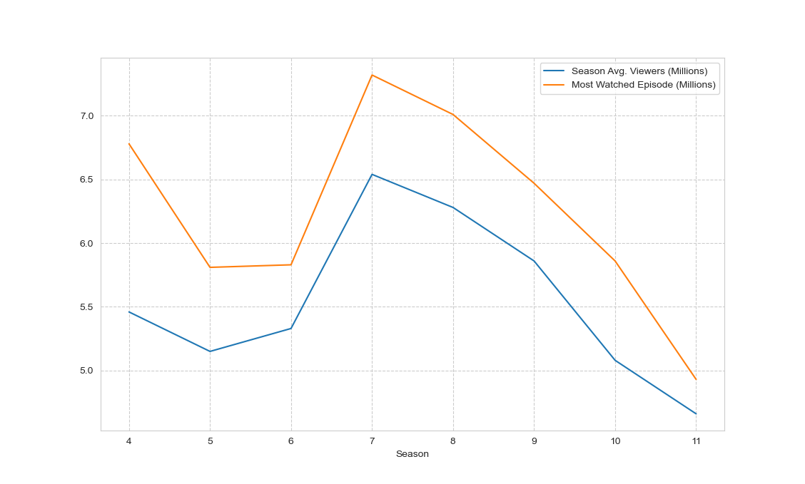After season 7 there has a steady trend of viewership dropping. From an average 6.6 million viewers with the highest viewed episode for the season at 7.6 million. Towards the end of season 11 with the average 4.4 million viewers with the highest viewed episode 4.8 million. This does show a downward trend, but with season 12 series premiere, it dominated the 8 p.m. slot and continued to dominate Wednesday nights. Also, to point out this is during COVID-19 season which expectations would be that the viewership should sky rocket, but that is unknown at the moment, with people being stuck at home and getting cabin fever. They could be living vicariously through these competitors.

Inspecting the locations of the Illinois Ninjas revealed to me that there was a good amount located in Chicagoland area. A popular Ninja whose nickname is “Flex” her full name is Jesse Labreck, and she current competes with another female with the most course completions. She was also pitted against another male competitor who is considered the best. In the end she lost not by a lot, but she was the first woman to compete against a male.

Jesse “Flex” Labreck is in Illinois with her fiancé a long with other Ninjas that are located in Naperville, Bolingbrook, Downtown Chicago, and other suburbs. In addition there are more Ninjas that are located in Wisconsin and Indiana which I could have including them, but this is about Illinois.

There is a abundance of gyms in the downtown Chicago area, but Ninja gyms are scarce. With the map below the traditional gyms are marked in blue.

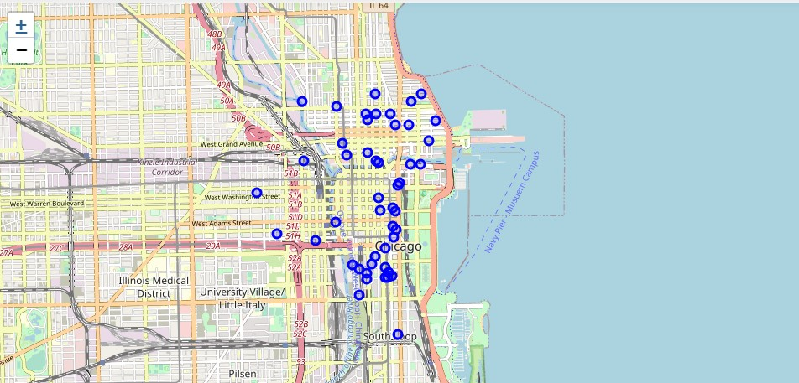

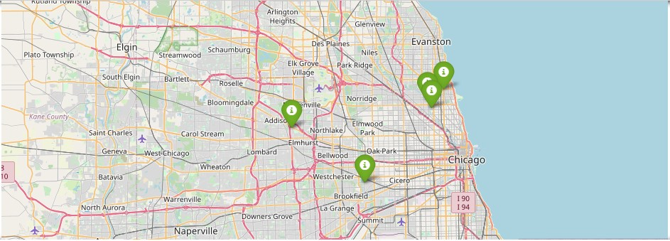The amount of Ninja gyms is scarce that are marked in green.

I believe to start out opening Ninja gyms around this area. These would be the key spots for the most coverage.

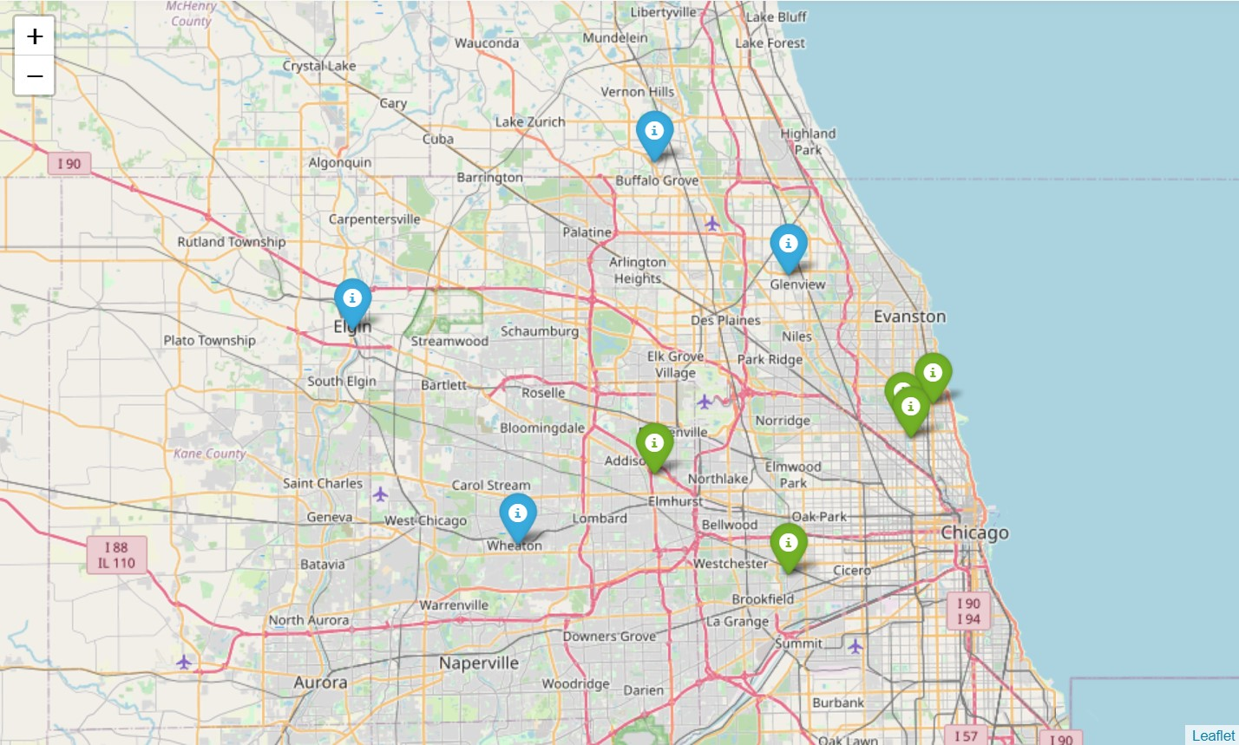

These spots are the areas around the popular Ninjas.

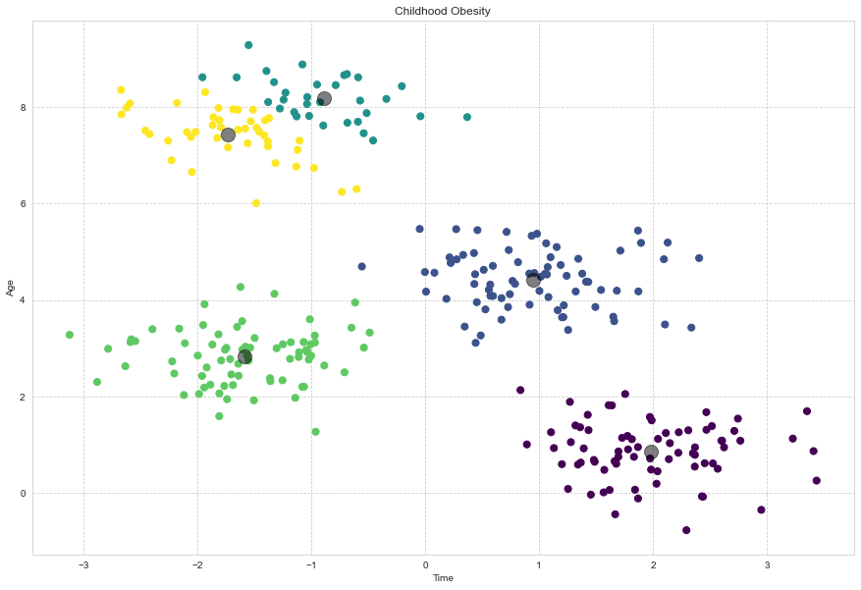During my expectation of the child obesity data I noticed that there was a rise from 1971 to 2012, where it plateaued. This is good, but society is not out of the woods. Since it plateaued doesn’t mean it is gone. It can go either way. If children can view Ninja as fun. This could be translated into exercise as fun, and hopefully help lower the obesity in children.

**Conclusion**

With the results of the data, it shows that Ninja gyms can be profitable given placed in the right area in Illinois. In addition, with the popularity could have many individuals and children that look up to these people. A diverse set of people from race, religion, gender, any kind of ailments that are detrimental to the physical. These people would like to perform these actions that they see on T.V. from their local town heroes.

There could be a huge profit with the ownership of gyms from the low start up costs, and low membership costs. The difference from a traditional gym and Ninja gym is that the traditional gym appeals mainly to adults. Ninja gyms appeal to all ages, and all kinds of people. It is not a place for the stereotypical “Meatheads”. It is nurturing culture that support each other. Which is appealing to people who want to start out.

The popularity may have dipped after the seventh season, but a large fanbase is still in Illinois. Also there are talks about having this competition become a Olympic sport solidifies the popularity in the sport. With the addition that it dominated Wednesday nights during COVID-19 shows that it is what the people enjoy watching.

In the end investing in Ninja gym around the Chicagoland area has a high chance that it could be profitable if managed right, and help reduce the obesity epidemic with disguising “Working out” as fun. Which I believe everybody could get behind.